# Analysis

Choose Analysis-> Analysis Variable Settings

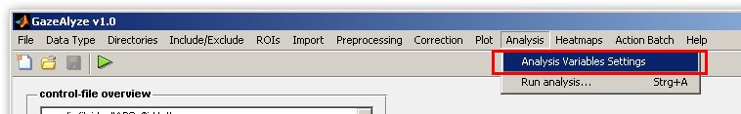

The following window will appear:

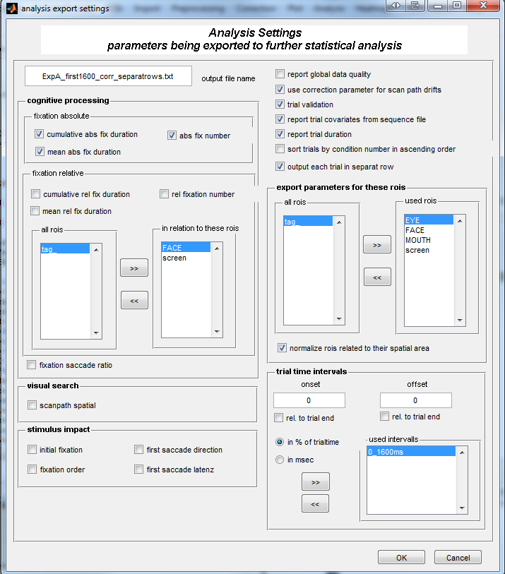

Choose Analysis-> Run analysis

